AI Hiring Portal - End-to-End Functional and Technical Documentation
(IIM Capstone Project)

1. Project Overview
The AI Hiring Portal is an intelligent recruitment system designed to automate and optimize the hiring lifecycle. The platform streamlines job postings, resume submissions, AI-based screening, and recruiter-candidate communication through an integrated UI, API, and AI system.
2. Project Purpose
- Simulate a real-world hiring platform for academic and internship experience.
- Expose interns to full-stack development (Frontend + Backend + AI integration).
- Provide hands-on learning in resume parsing, JD matching, and business logic automation.
- Help recruiters reduce time and cost per hire through AI-based screening.

3. User Roles & Responsibilities
Role | Responsibility
Business Unit | Posts job descriptions
Recruiter | Screens and manages applicants, configures match thresholds
Candidate | Applies for jobs by uploading resumes and providing details
AI Engine | Analyzes resumes, compares with JD, and assigns a match score

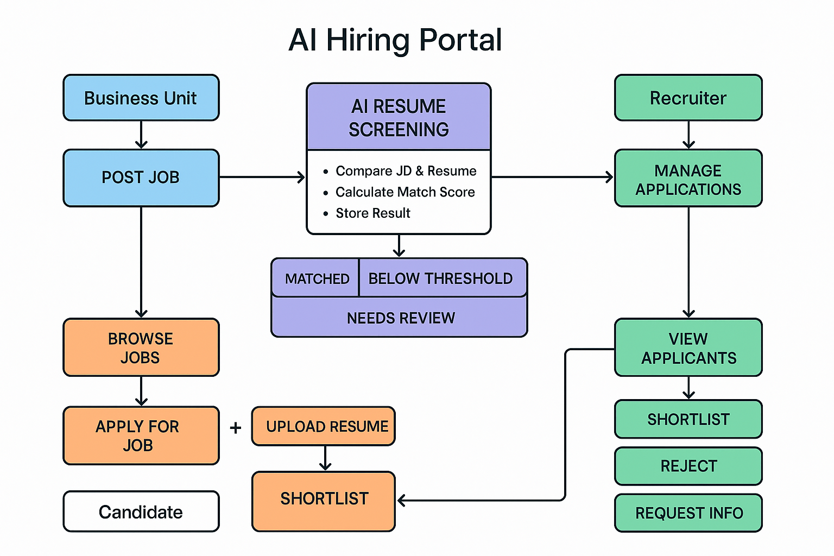

4. Key Workflows
4.1 Job Posting
- Actor: Business Unit
Steps:
  - Fill JD form with title, required skills, experience, location, budget.
  - Submit JD for recruiter review.
  - Recruiter approves or edits.
  - JD is published on the job portal.
4.2 Candidate Application
- Actor: Candidate
- Steps:
  - Browse live job listings.
  - Fill application form + upload resume.
  - System generates unique Application ID (e.g., APP-2025-0001).
  - Resume stored under structured folder system.
  - Confirmation email sent.
4.3 Resume Screening
- Trigger: New resume upload.
- Steps:
  - JD and resume are parsed.
  - Semantic matching performed using NLP.
  - Match score calculated (0-100).
  - Categorized as: MATCHED, BELOW THRESHOLD, NEEDS REVIEW.

4.4 Recruiter Dashboard
- View all applicants per job.
- Filters:
  - Score above threshold
  - Skill match %
  - Years of experience
- Resume health report:
  - Keyword match summary
  - Missing critical skills
  - Suggestions for CV improvement
- Actions: Shortlist, Reject, Request Info

4.5 Candidate Communication
- Shortlist: Auto-email with interview availability form.
- Reject: Polite template-based rejection email.
- Request Info: Custom message with follow-up request.

4.6 Interview & Feedback (Phase 2)
- Calendar sync (Google/Outlook)
- Feedback form submission
- Candidate status: Interviewed, On Hold, Rejected, Selected

5. Technical Architecture
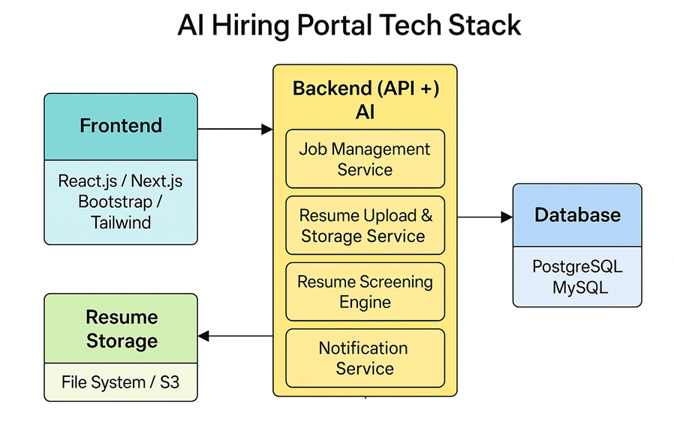
5.1 Frontend (React.js / Next.js)
- JD Posting Form
- Job Listings Page
- Resume Upload Form
- Recruiter Dashboard
- Resume Report View

5.2 Backend (Python + FastAPI)
- Job Management APIs
- Resume Upload & Storage APIs
- Resume Screening Engine
- Threshold Config APIs
- Notification Service (SMTP/WhatsApp API)

5.3 AI/NLP Resume Matching
- Libraries: Sentence Transformers, spaCy, HuggingFace
- Techniques:
  - TF-IDF for keyword overlap
  - BERT embeddings for semantic similarity
  - spaCy NER for skill extraction

Sample Output:
{
"match_score": 85,
"status": "MATCHED",
"missing_keywords": ["Azure DevOps", "REST API"],
"highlighted_keywords": ["Python", "Flask", "ML"]
}

6. Database Design
Table Name | Key Fields
job_postings | id, title, skills_required, experience, budget, location, status
applications | id, job_id, candidate_name, email, resume_path, score, status
resume_analysis | application_id, match_score, missing_keywords, improvement_suggestions
recruiters | id, name, email, assigned_job_ids

7. Resume Storage Structure
- Folder Naming Convention: resumes/{job_id}/{application_id}.pdf
- Future enhancement: Use AWS S3 for scalable, secure storage

8. Admin Panel (Phase 2)
- Role-based access (Admin, BU Head, Recruiter)
- Manage job postings and thresholds
- View hiring analytics: time-to-fill, score averages, funnel efficiency

9. AI Use Case Summary & Business Impact
Area | Traditional Time | AI Portal Time | Savings | Remarks
Resume Screening | ~6 hrs/100 resumes | ~15–20 mins | 90% time saved | Instant scoring, scalable logic
JD Posting & Approval | ~1 hr | ~5–10 mins | 80% saved | Centralized, approval flow
Candidate Filtering | Manual review | Filter-based | 75% saved | Based on score/skills/exp.
Communication | Manual emailing | Auto-notify | Time-efficient | Templates used smartly

10. Feature Roadmap
Phase | Features
1 | Resume Screening + JD Posting & Shortlisting
2 | Resume Suggestions & Skill Gap Detection
3 | JD-based Interview Question Generator
4 | Candidate Chatbot
5 | Career Path Recommender

11. Future Enhancements (Post MVP)
- Job Board Integrations (Naukri, LinkedIn)
- Resume Builder Tool for Candidates
- Interview Scheduling Calendar API
- Offer Letter Generation
- Role Recommender AI

12. Estimated Pricing / Cost-saving Summary
Area | Tech Used | Cost (Monthly) | Notes
Hosting | Vercel / Render / EC2 | ₹0–₹2,000 (free tiers available) | Frontend & Backend
Resume Storage | AWS S3 | ₹0.023/GB | ~₹50 for 2000 resumes
Email | SMTP2GO / SendGrid | Free up to 100/day | ₹500+ if scaling
AI Processing | HuggingFace / OpenAI / Custom BERT | ₹0 (open models) – ₹5,000 | Depending on API or local inference
DB (Cloud) | RDS / Supabase | ₹0–₹1,000 | Free tiers + backups

13. Conclusion
The AI Hiring Portal is a comprehensive simulation of modern recruitment workflows. By combining frontend UX, backend logic, and AI-powered screening, the platform delivers measurable improvements in time, cost, and quality of hire. It is ideal for both educational capstone exposure and real-world prototype use.

Reference screens for phase -1:

